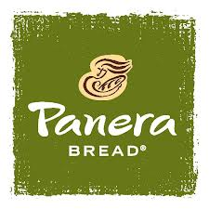

DRIVER UNIFORM EXPECTATIONS & AGREEMENT

Employees are expected to come into orientation IN UNIFORM. Please use this list to make certain that you have met our standards prior to coming to orientation. If you are not in the accepted uniform at orientation, then you have only one other opportunity to correct your uniform.

___ Orange Short-Sleeved Panera Polo (Polos will be issued during orientation)

___ Khaki Pants “Docker style”. These must be clean and pressed as well as fit correctly. Baggy or tight
fitting pants will be found unacceptable. Skinny pants are unacceptable.

___ Plain/Solid Black Belt. Belt may not have designs or adornments (ie. studs, holes, etc).

___ Black Shoes. Must be closed-toe, closed-heel, and slip free. Ballet Flats are not acceptable

___ Hair must be neat, clean and tucked in hat, prior to entering the café and/or Planet Bread.

___ Jewelry is not permitted. (Wedding rings are an exception)

___ Visible Tattoos are not permitted unless approved by the Director or Delivery Ops Manager.

___ Facial piercings are prohibited. (This includes tongue rings)

*Women Only:

___ Earrings: Women are permitted one earring per ear. Earrings may only be small studs.

___ Nail polish is only permitted when not chipped. Also, no extreme colors will be permitted.

*Men Only:

___ Hair may not go below the ear.

___ Facial Hair is not permitted. Shaving prior to work each day is expected.

I have read and FULLY UNDERSTAND the above agreement and expectations set forth in this policy.

Signed Name: __________________________ Signed Name: ___________________________
(Associate) (Manager)

Printed Name: __________________________ Printed Name: ___________________________
(Associate) (Manager)

Date: ____________ Date: ____________

